## 1. Please write a query for how many customers started the subscription flow each

## month as well as the number and % that completed.

*The months are presented as number of each month(Jan - 1, Feb - 2, etc)*

*Guests that entered the subscription flow are the total number of rows in subscriptions table for that month.*

*Last 2 parameters are calculated as per logic given in exercise.*

SELECT

extract(month from date_created) AS "Month",

COUNT(*) AS "Guests that entered subscription flow",-- total customers who started subscription flow

SUM(

CASE WHEN date_initialized IS NOT NULL

THEN 1

ELSE 0

END) AS "No. of guests who subscribed",--total subscriptions

ROUND(SUM(

CASE WHEN date_initialized IS NOT NULL

THEN 1

ELSE 0

END)*100.0/COUNT(*),2)||'%' AS "Percent subscriptions"

FROM thistle_web.subscriptions_subscription

GROUP BY

extract(month from date_created)

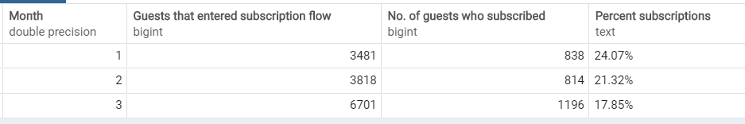

## 2. What is the signup success rate (# of people signing up for a subscription vs. all

## people who enter the checkout flow) for meat vs. veg plans?

*A group by clause with protein type gives the answer for this question tweaking the SQL in 1st question.*

SELECT

protein_type,

COUNT(*) AS "Guests that entered subscription flow",-- total customers who started subscription flow

SUM(

CASE WHEN date_initialized IS NOT NULL

THEN 1

ELSE 0

END) AS "No. of guests who subscribed",--total subscriptions

ROUND(SUM(

CASE WHEN date_initialized IS NOT NULL

THEN 1

ELSE 0

END)*100.0/COUNT(*),2)||'%' AS "Sign up success rate"

FROM thistle_web.subscriptions_subscription

GROUP BY

protein_type

## 

## 3.Please calculate how many customers cancel within 14 days of signing up.

*A simple count of total customers where difference in cancelled date and subscription date is less than or equal to 14.*

SELECT

SUM(

CASE WHEN DATE_PART('day',c.date_cancelled::timestamp-s.date_initialized::timestamp) <= 14

THEN 1

ELSE 0

END

)

FROM

thistle_web.subscriptions_subscription "s"

JOIN

thistle_web.subscriptions_subscriptioncancellation "c"

ON s.id = c.subscription_id

## 

## 4. Please calculate retention by weekly cohort.

*This report starts from day first subscription was added to the subscription table.*

*Cohort total is counted as the number of subscriptions on the first day.*

*‘Week’ column refers to the first day of each new week.*

*Active subscriptions are counted as ‘subscriptions started before or on a given day’ minus ‘subscription cancelled on or before that day’. (given day = first day of each week in table)*

WITH first_day(first_day,last_day) AS

(

SELECT

MIN(date_initialized)::date,

MAX(date_initialized)::date

FROM

thistle_web.subscriptions_subscription

),

first_dow (first_dow) AS

(

SELECT

dow

FROM

public.etl_calendar,first_day

WHERE

day=first_day.first_day

),

start_cohort (scount) AS

(

SELECT

COUNT(*)

FROM thistle_web.subscriptions_subscription,first_day

WHERE date_initialized::date <= first_day.first_day

)

SELECT

first_day "cohort",

day "week",

DATE_PART('day',day::timestamp-first_day::timestamp)/7+1 "week_number",

start_cohort.scount "cohort_total",

start_cohort.scount-

(SELECT count(*) FROM thistle_web.subscriptions_subscriptioncancellation

WHERE date_cancelled <= day AND date_cancelled>=first_day)+

(SELECT count(*) FROM thistle_web.subscriptions_subscription

WHERE date_initialized <= day)"active_subs",

(start_cohort.scount-

(SELECT count(*) FROM thistle_web.subscriptions_subscriptioncancellation

WHERE date_cancelled <= day AND date_cancelled>=first_day)+

(SELECT count(*) FROM thistle_web.subscriptions_subscription

WHERE date_initialized <= day))/start_cohort.scount*1.0 "active_percent"

FROM

public.etl_calendar,first_dow,first_day,start_cohort

WHERE

dow=first_dow.first_dow

AND day::date < last_day

